There is an issue when editing department  
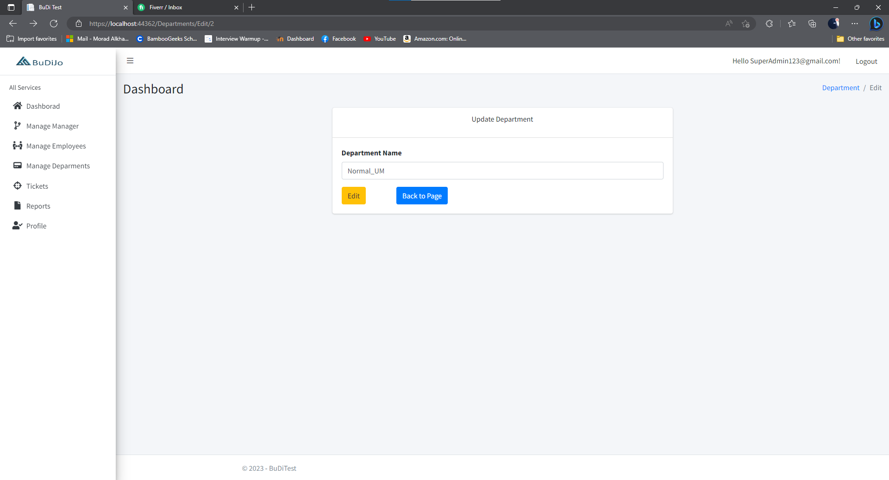  
once you click on back to page it will show this error:  
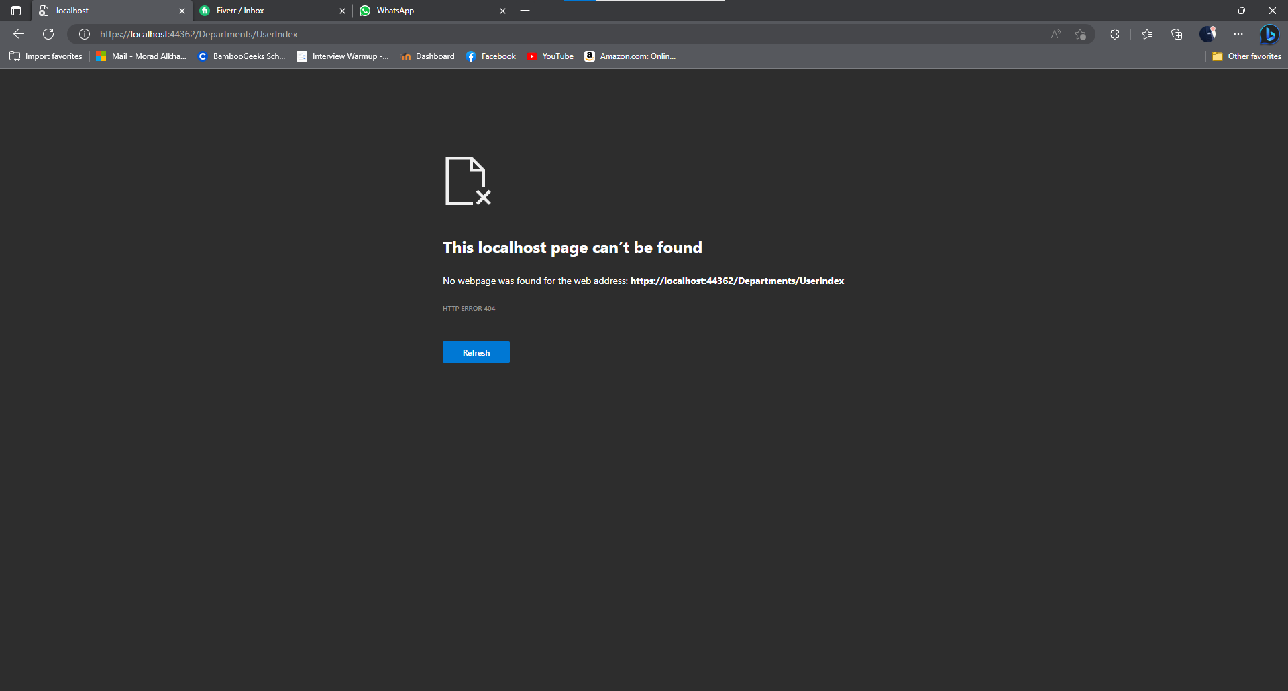

When creating an employee from manager page  
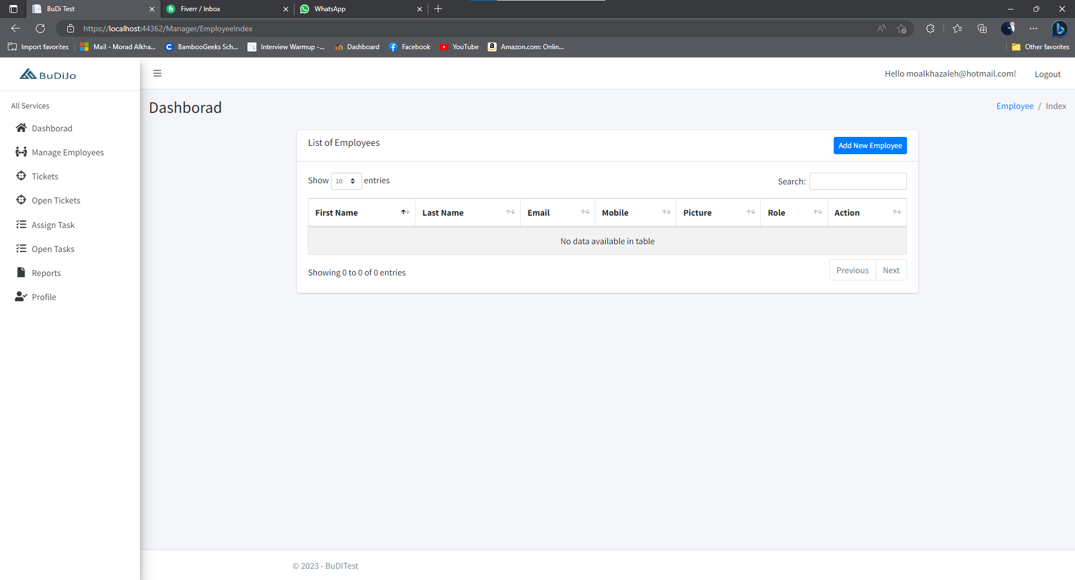

It won’t show the employee details in the list of employee

In the employee main page, when you click on clock-in button it will change to clock-out but if you refresh the page it will be changed to clock-in again, also it should record the current time with employee information but it doesn’t show anything

Plus when clicking on both my open tasks & my open tickets it don’t show anything  
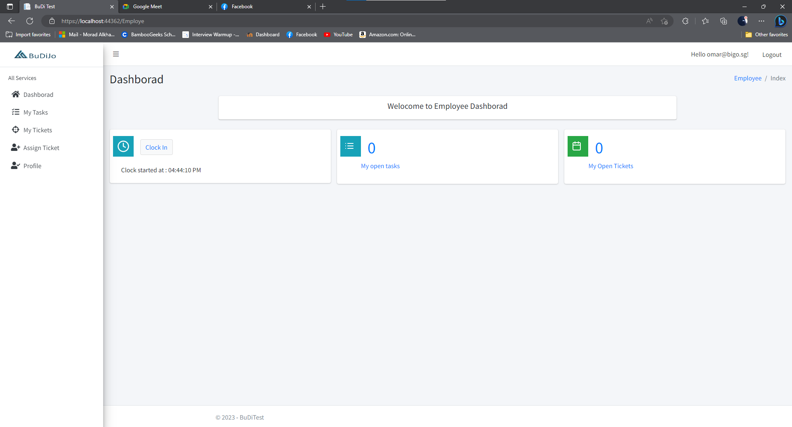

There is no option to create a ticket for manager on the side bar, as it must have access to this option, plus there is no option to create a task from manager side.

Ticket & open tickets both have the same page without any option to add a new ticket or assign ticket

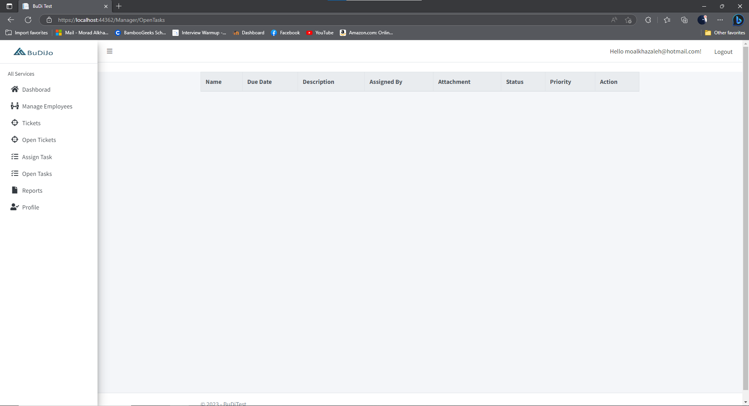

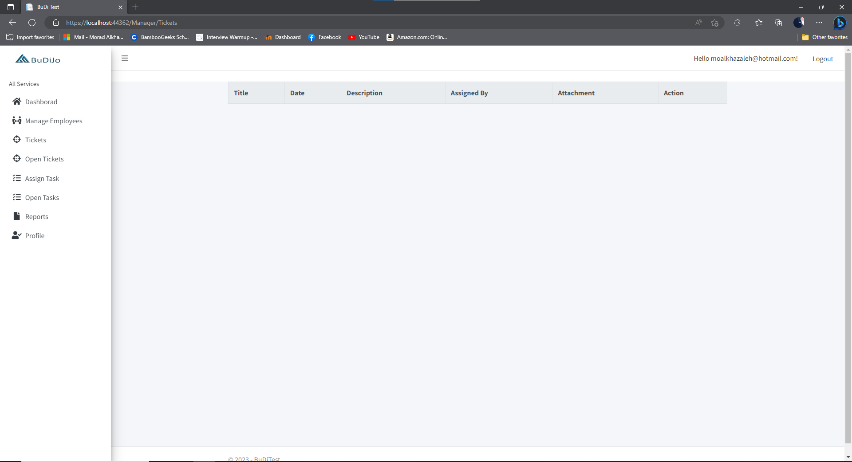

In the manager profile when clicking on employee list, it will show all of the employees even the employees of other departments, It should only view list of employee within the same department only not all of other departments.

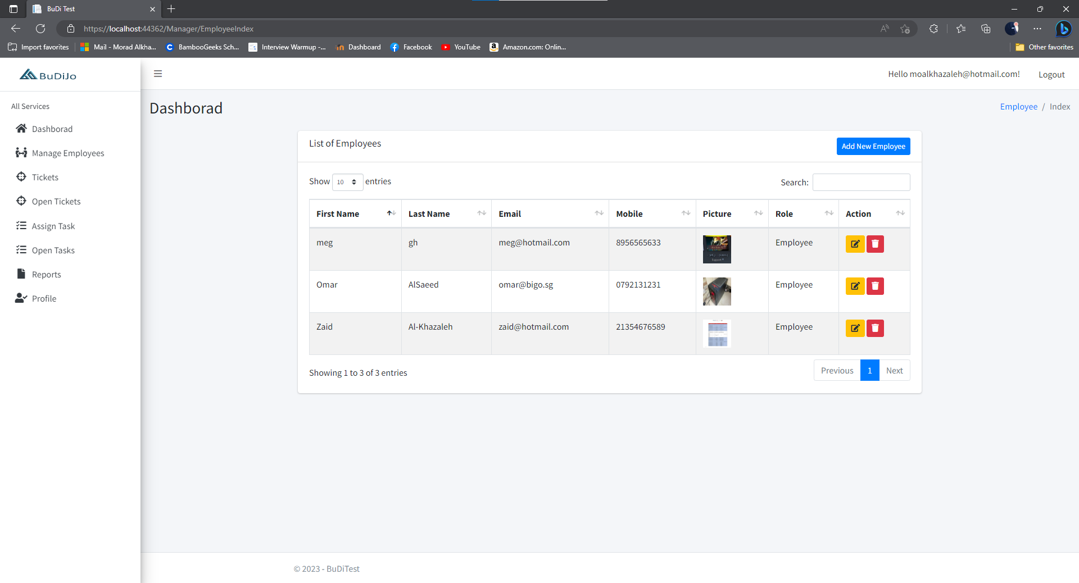

Report option is not working   
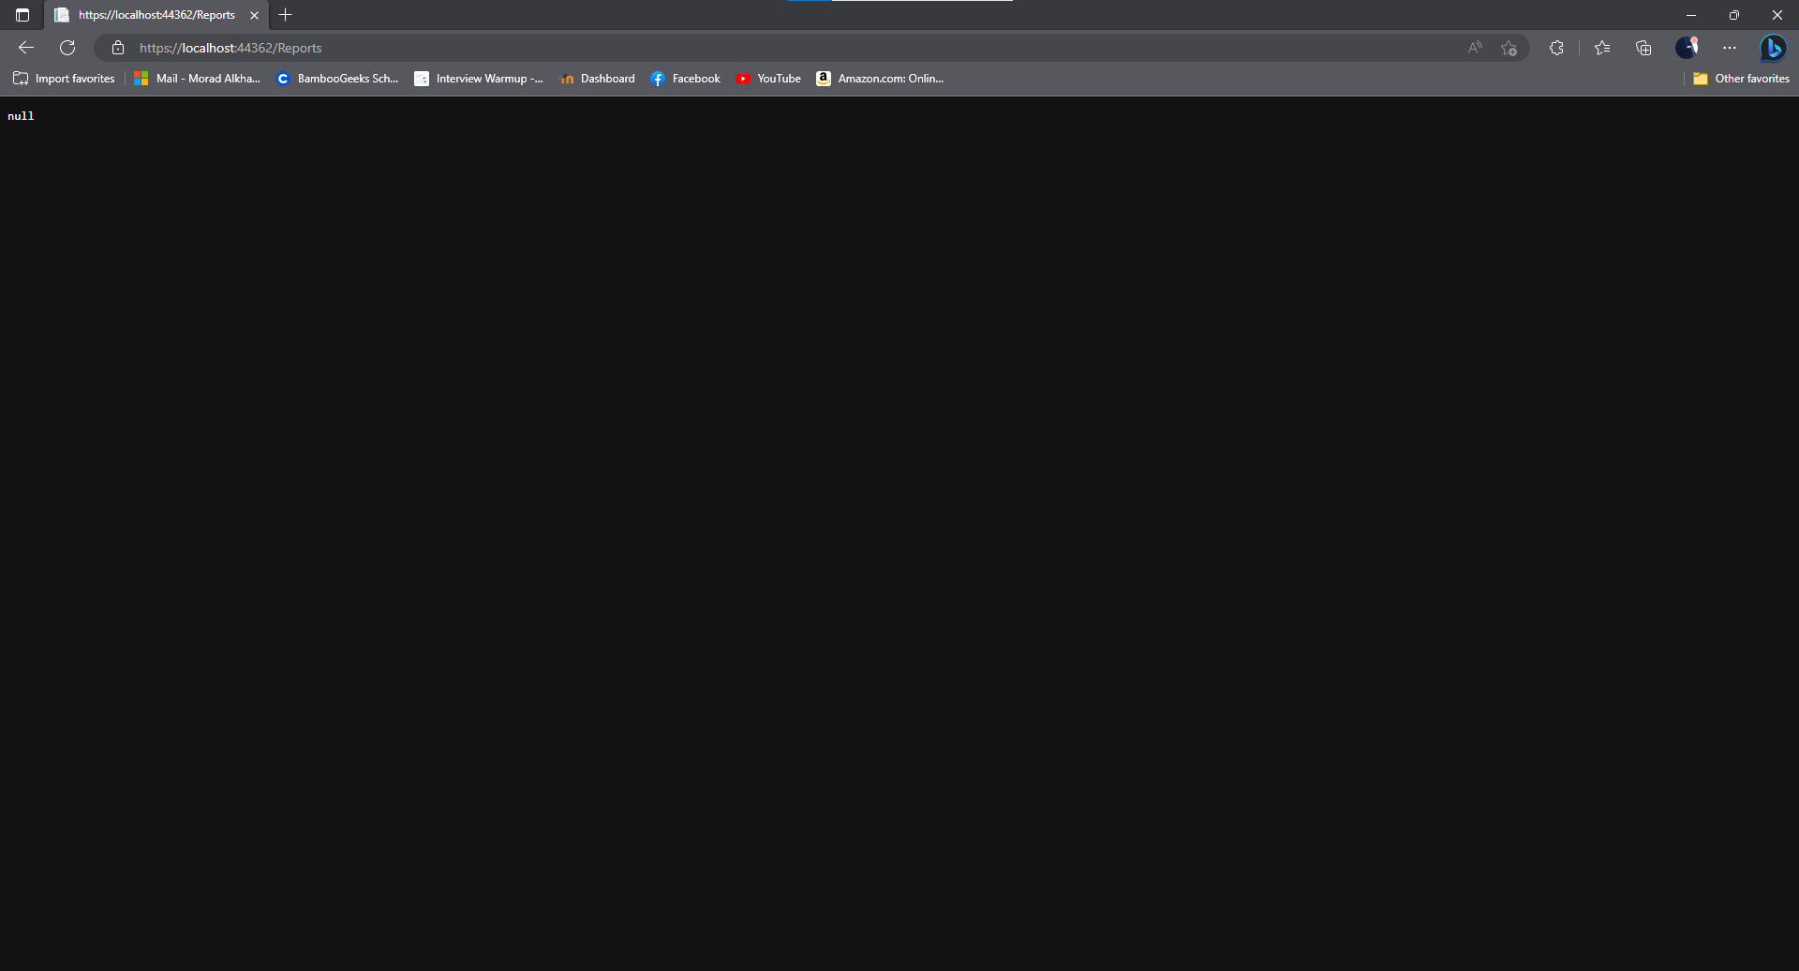  
  
assign task option not working   
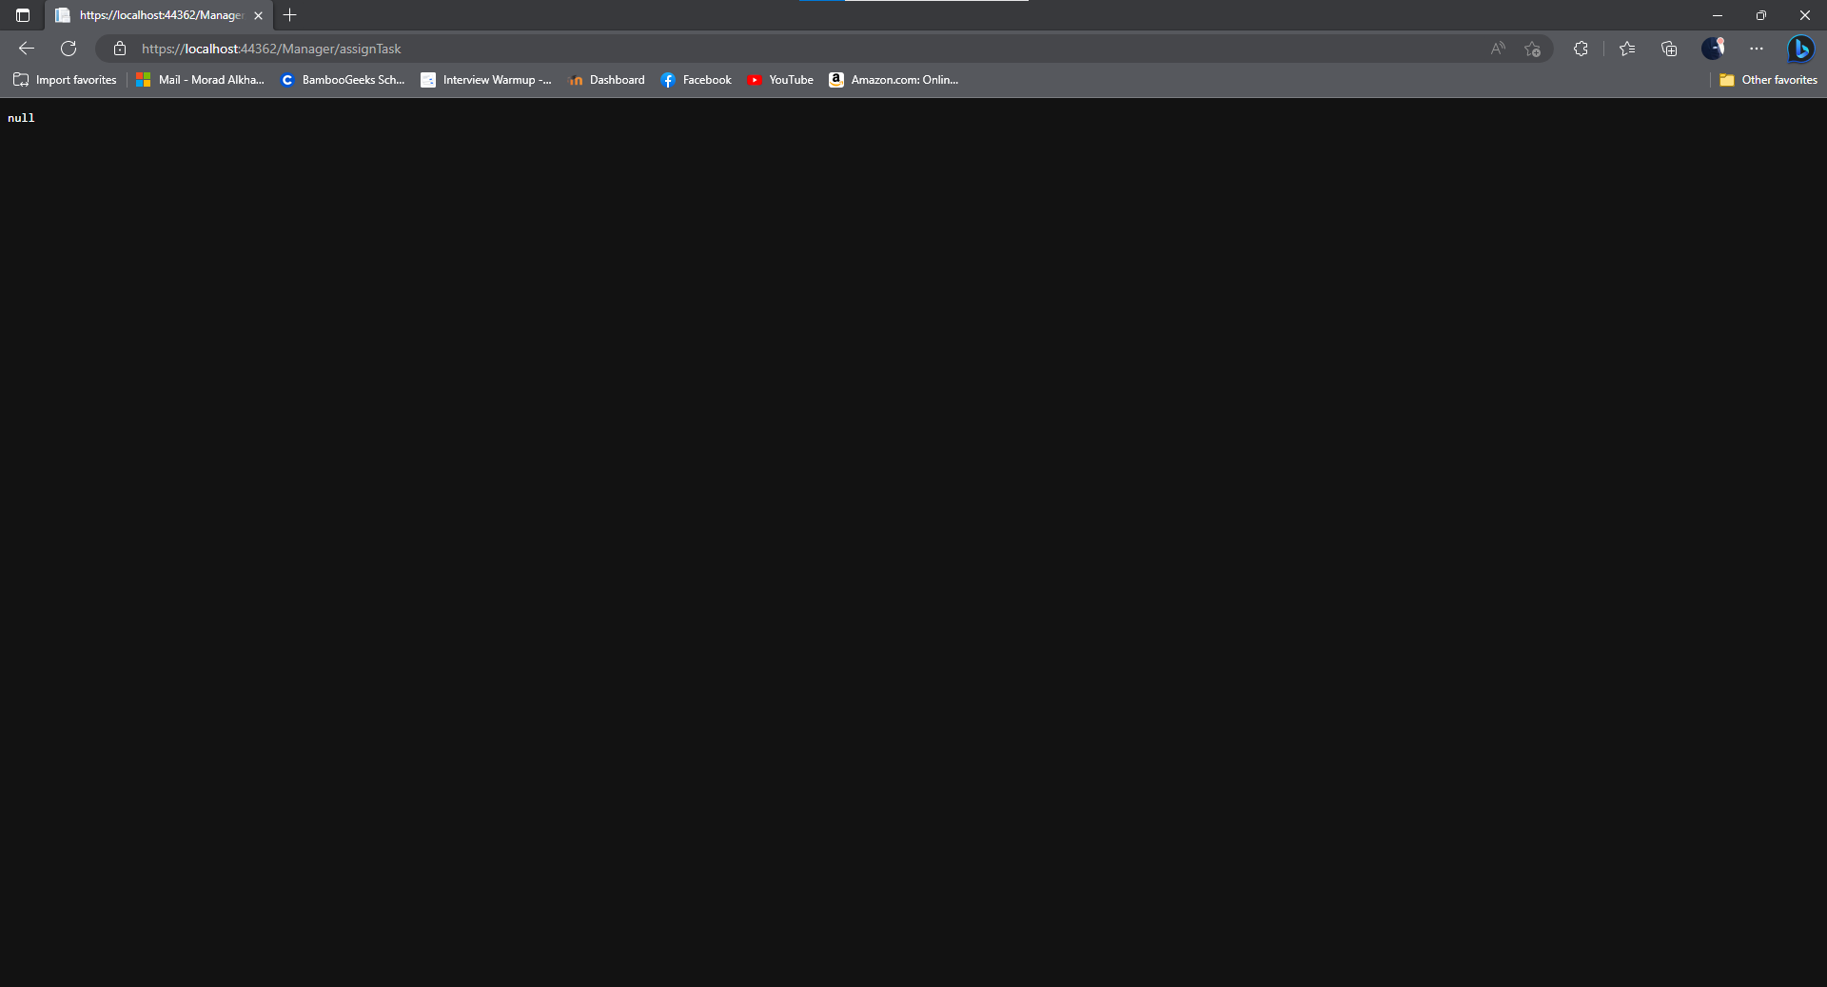

For the dashboard Employee will be greeted with a welcoming massage including his name, and the main page will show total tickets that has raised by his department, and how many are pending and total solved for his team with a chart showing his personal solving for the tickets. (each department will show different numbers since the total assigned tickets for each team will be different).

The clock-in button should be included in the side bar as a separate page, below is an example of how it should look   
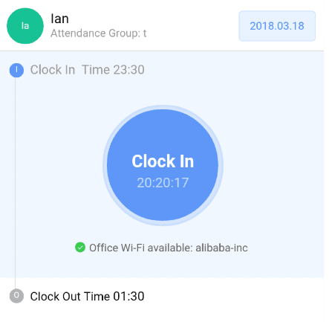  
there is live time inside the button and once it’s clicked it will show a brief pop-up showing employee name plus the current time, and it will change status to clock-out, even if the page is refreshed it will keep the information of it.

For change email option :  
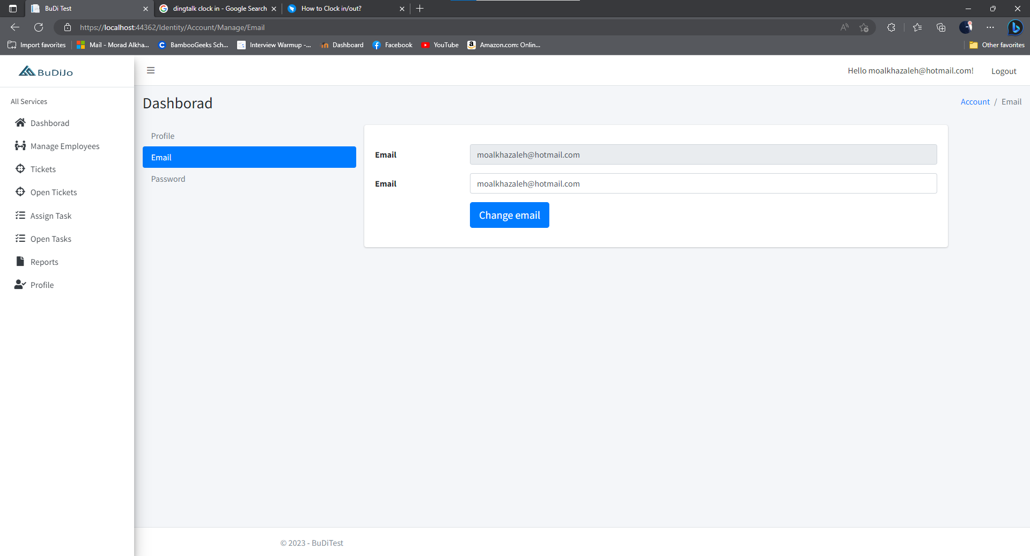

It should be removed from both employee & manager, and should add the option to change employee picture in the profile settings

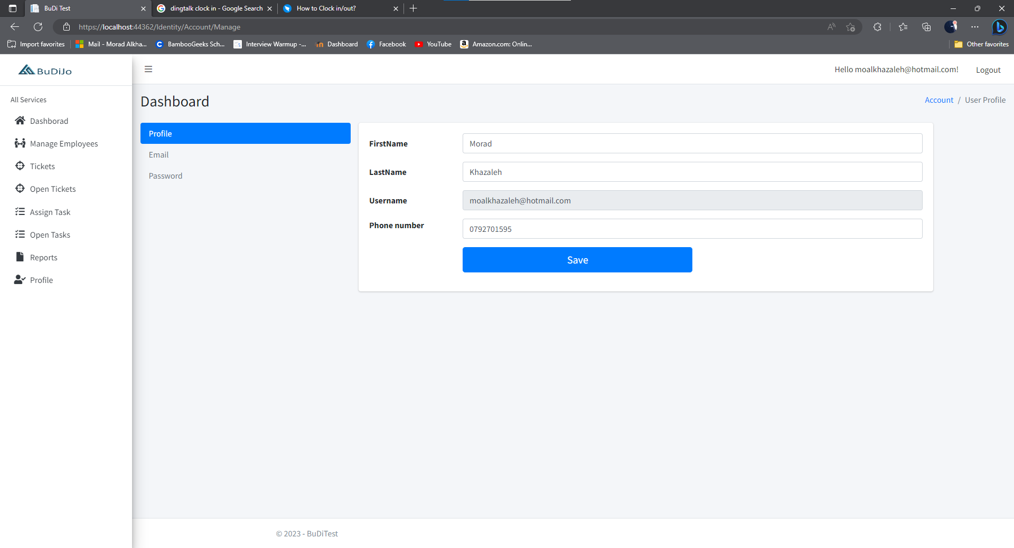

There is no option to add username in the add employee page which should be added.

In the employee page assign ticket, when trying to assign the ticket to employee within the same department it doesn’t show any options   
  
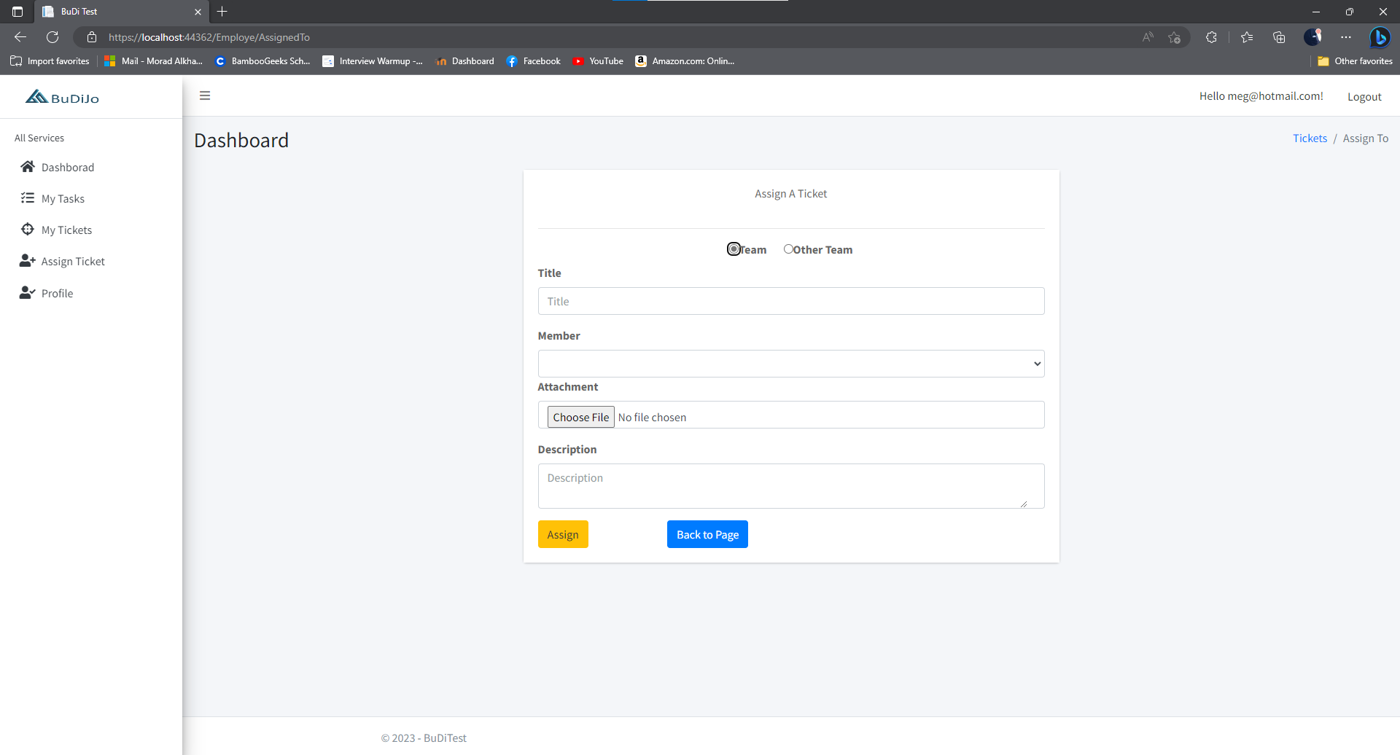

Minor fixes in the UI :  
in the welcoming at the top right it should show employee name instead of his email  


The footer should be changed to the web-app name BuDiJo instead of BuDiTest   
  
this should be updated for all the pages  
  
side bar color should be (background-image: linear-gradient(to right bottom, #5979aa, #4667a0, #355695, #24448a, #12337e); instead of white color.

The same will be applied to the login page   
background-image: linear-gradient(to right bottom, #5979aa, #4667a0, #355695, #24448a, #12337e);